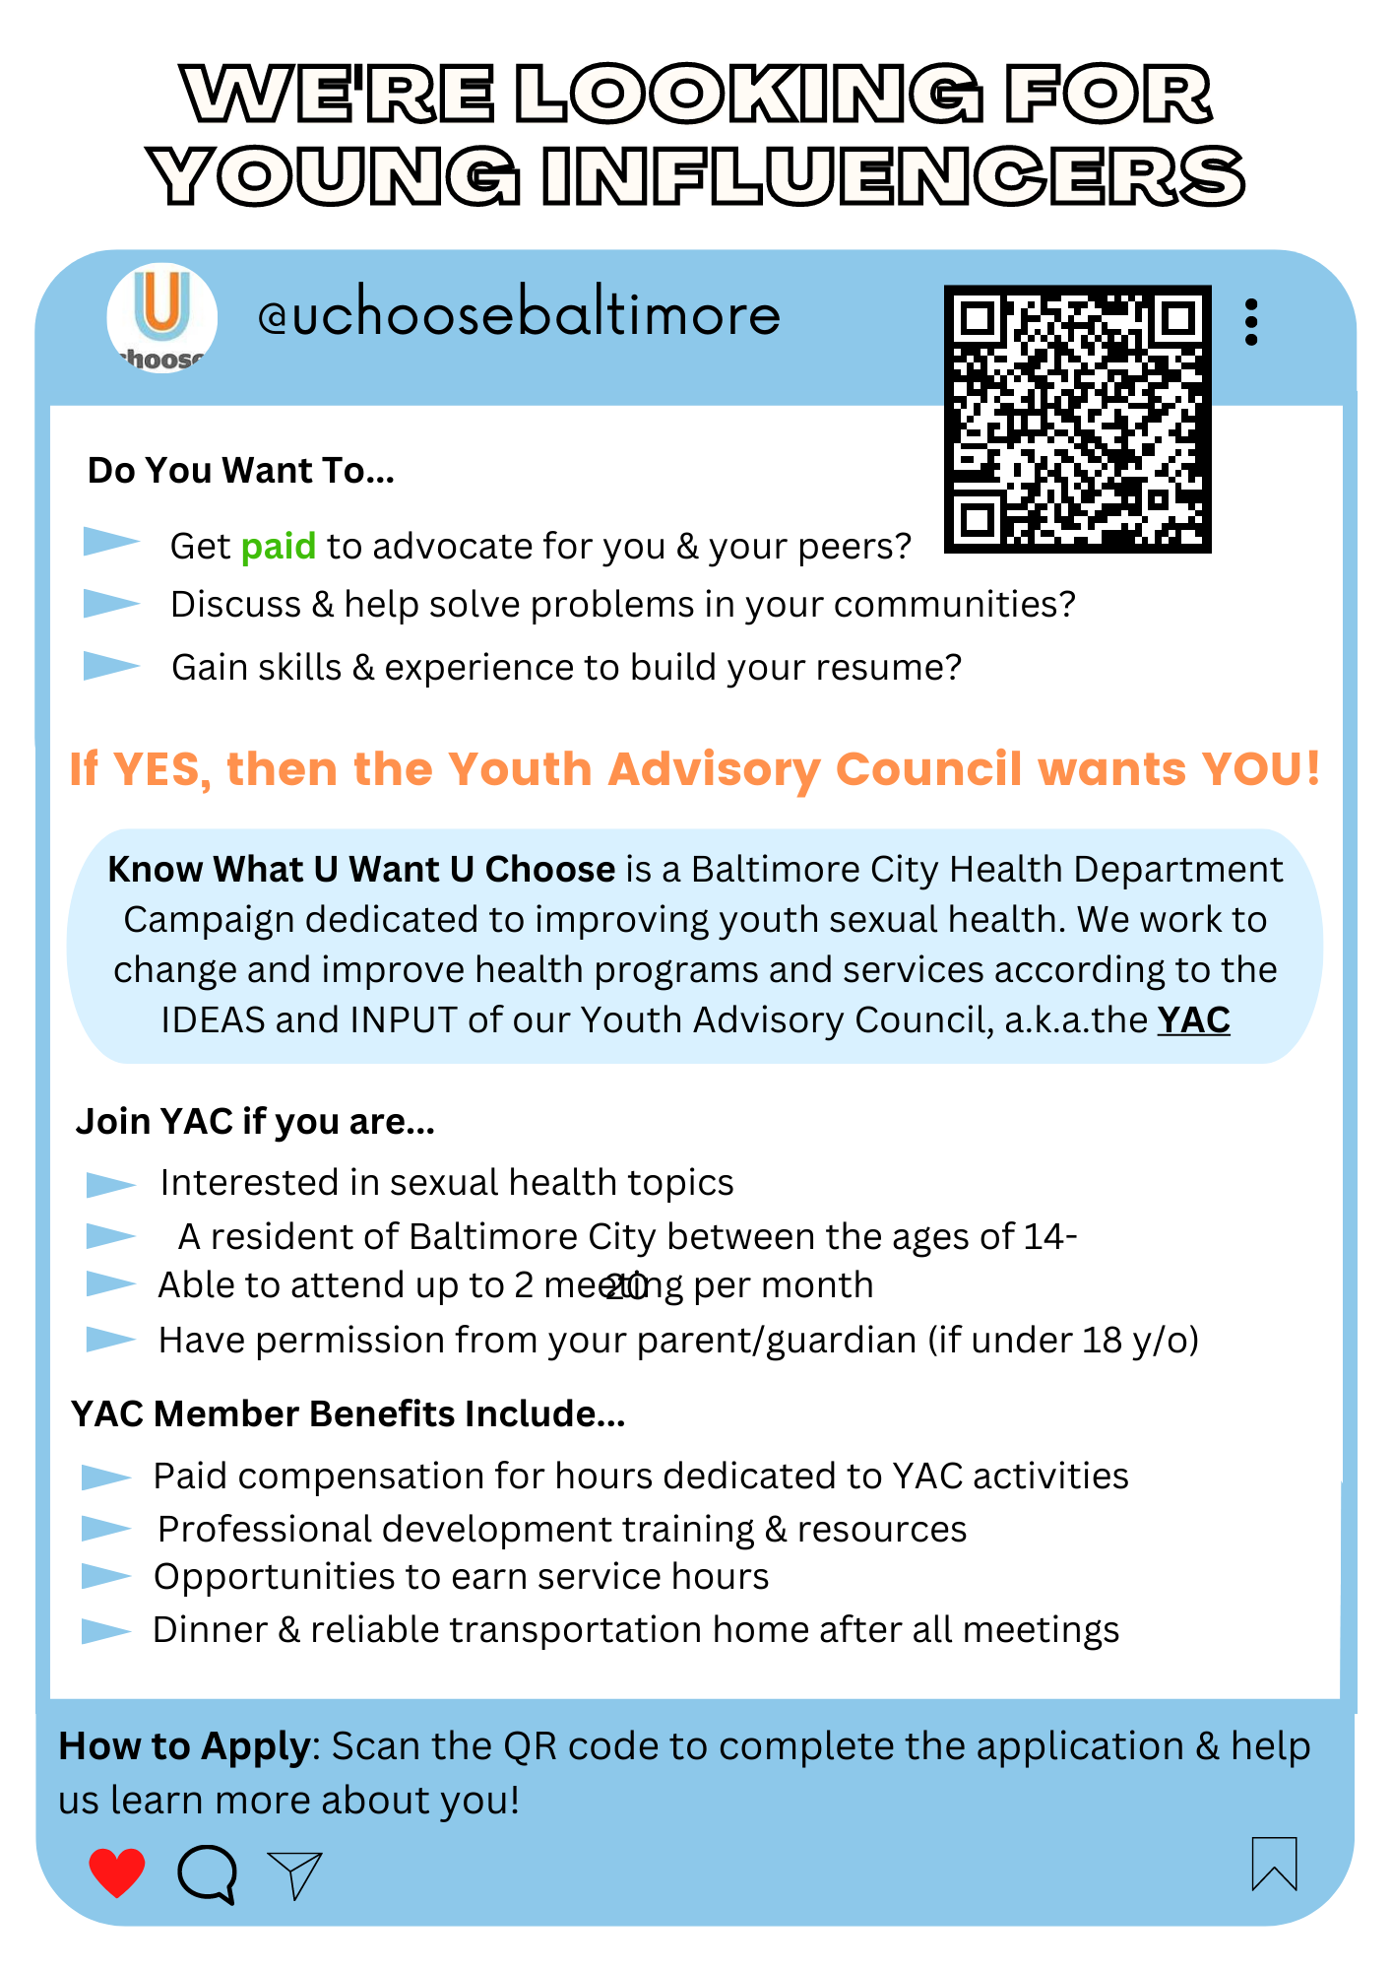

Submit your application and additional materials to the email provided below.
Additional Materials Include:
  - All applicants - Most recent report card/progress report demonstrating a 2.0 GPA or above
  - Below 2.0 GPA applicants only - Letter of recommendation from a teacher, school staff, or adult mentor required to be considered

Youth Advisory Council (YAC) Membership APPLICATION FORM

Please email completed application (incl. additional materials) and refer any questions to the following individuals:
Karis Harrison karis.harrison@baltimorecity.gov
Victoria Paniagua victoria.paniagua@baltimorecity.gov

About You

Applicant’s Name: ___________________________

Birthdate (mm/dd/yyyy): _____ / _____ / ______

Pronouns (example: he, she, they):________

Address: __________________ City:______________ State:_____ Zip:________

Phone Number (xxx)-xxx-xxxx): (_____) - _____ - ______

Email Address: ________________________

What language(s) do you speak? _______________________________

School Information

Do you attend school?*** Yes____ No____

***If you are not in school, you are still eligible for YAC.

If YES:

What is the school name? _____________________

What grade are you in? _________

Do you have a job?*** Yes____ No____

If YES:

What days do you work? _____________________

More About You
Please answer each of the following questions in 2-3 sentences.
- Why are you interested in joining the youth advisory council (YAC)? *

- What would you like to get out of the yac? *

- Describe some of your hobbies and/or interests. *

- What career choices are you interested in pursuing? Why? *

- What else do we need to know about you, that we have not already asked?
Parent/Guardian Information (if applicant is under 18 years of age)

Parent/Guardian Name: ________________________

Address: __________________ City:______________ State:_____ Zip:________

Phone Number ((xxx)-xxx-xxxx): (_____) - _____ - ______

Email Address: ________________________

What language(s) do they speak? _______________________________

I give permission for my child to participate in the Baltimore City Health Department Youth Advisory Council.

X ____________________________________ DATE ________________

Media Release Information

YAC members are given the opportunity to participate in several outreach events & media projects, during which photographs and videos are taken to promote the UCHOOSE campaign. Please complete the following name/image release form and include a parent/guardian signature if you are under 18.

